**Pest Identification Android App Using Deep Learning Algorithms(CNN)**

Were Vincent Ouma

9th May 2024

**Abstract**

The Pest Identification Android App project, named Pestify, aims to revolutionize pest identification and management through the integration of deep learning algorithms into a user-friendly mobile application. This dissertation provides an in-depth exploration of the development process, challenges faced, and outcomes achieved. The project's primary objective is to create an intuitive and efficient tool for users to identify pests accurately and swiftly using their smartphones' camera capabilities. By leveraging deep learning techniques, the app automates the identification process, offering users real-time insights into the detected pest's species, potential harm, and recommended management strategies.

Through a comprehensive literature review, this dissertation examines existing pest identification techniques, the role of deep learning in this domain, and the landscape of current pest identification apps. Key challenges and opportunities in the field are identified, laying the groundwork for the project's methodology.

Methodologically, the project encompasses data collection, preprocessing, and the development of a robust deep learning model tailored for pest identification. The training and evaluation process involves extensive testing and validation to ensure the model's accuracy and reliability. Integration with the Android app entails seamless user experience design and efficient implementation of the deep learning algorithm. Results and discussions delve into the model's performance evaluation, app integration process, user feedback, usability testing outcomes, and analysis of app performance, scalability, and cost implications. Legal, social, ethical, and professional considerations surrounding data protection, public interest, privacy, and project management are also addressed. Feasibility studies explore business goals, information collection, system development methodologies, and proposed solutions, paving the way for the exploration and engineering stage. Post-project evaluations summarize system deliverables, lessons learned, system evaluations, future enhancements, and concluding remarks.

In conclusion, the Pestify project represents a significant advancement in pest management technology, offering users a convenient and effective tool for pest identification and mitigation. Future research directions include further enhancements to the app's functionality and expansion into new pest species and geographical regions.

**Aknowledgment**

We express our sincere gratitude to all those who have contributed to the realization of this project.

First and foremost, we would like to thank our supervisor **Dr. Were Vincent** for their guidance, support, and invaluable insights throughout the duration of this project. Their expertise and encouragement have been instrumental in shaping the direction and success of this endeavor. We extend our appreciation to the Kenyatta University for providing the necessary resources, facilities, and infrastructure essential for conducting this research.

Our heartfelt thanks go to the participants and volunteers who generously shared their time, feedback, and expertise during the user feedback sessions and usability testing of the Pestify app. Their input and suggestions have been invaluable in refining and improving the app's functionality and user experience. We are grateful to the farmers, agricultural experts, and industry professionals who provided valuable insights, domain knowledge, and real-world perspectives that informed the development and application of Pestify in agricultural practices.

Special thanks to our colleagues and friends who provided encouragement, support, and constructive feedback throughout the project's journey. Finally, we would like to express our gratitude to our families for their unwavering support, understanding, and encouragement during the course of this project. This project would not have been possible without the collective efforts and contributions of everyone involved, and for that, we are truly thankful.

**Table of Contents**

Catalog

**CHAPTER 1 6**

**CHAPTER 2 15**

**I. *Variability in Pest Characteristics* 23**

***II. Limited Training Data* 24**

***III. Environmental Factors* 24**

***IV. Generalization and Transfer Learning* 25**

***V. User Engagement and Adoption* 25**

***VI. Privacy and Data Security* 26**

**CHAPTER 3 27**

***3.1 Data Collection* 27**

***3.2 Data Preprocessing* 29**

***3.3 Deep Learning Model Architecture* 34**

***3.4 Training and Evaluation* 37**

***3.5 Integration with Android App* 39**

**CHAPTER 4 44**

**CHAPTER 5 52**

**CHAPTER 6 53**

***6.2 Collect and Analyze the Information:* 53**

***6.3 Terms of References:* 53**

**CHAPTER 7 55**

**CHAPTER 8 57**

**References 59**

**Appendices 61**

**CHAPTER 1**

**1. Introduction**

***1.1 Background and Motivation***

Pest infestation poses a significant threat to agricultural productivity, food security, public health, and ecosystem stability worldwide. Identifying and managing pests promptly is crucial for mitigating their adverse impacts and ensuring sustainable agricultural practices. Traditional methods of pest identification, relying on manual inspection and expert knowledge, are often time-consuming, labor-intensive, and prone to errors. As technology continues to advance, there is a growing need for innovative solutions that leverage cutting-edge techniques to streamline pest identification processes and empower stakeholders with timely and accurate information.

The development of the Pestify Android App emerges from the intersection of agriculture, technology, and environmental sustainability. With the proliferation of smartphones and the increasing ubiquity of digital solutions, mobile applications have become powerful tools for addressing a wide range of challenges, including pest management. By harnessing the capabilities of deep learning algorithms and mobile computing, Pestify aims to revolutionize pest identification by providing users with a convenient, accessible, and reliable means of identifying pests in real-time.

The motivation behind the Pestify project stems from the pressing need to bridge the gap between traditional pest identification methods and modern technological advancements. Conventional approaches to pest management often rely on manual observation and expert judgment, limiting the scalability, accuracy, and accessibility of the process. Moreover, the lack of widespread access to specialized expertise and resources in rural and remote areas exacerbates the challenges associated with pest identification and control.

By developing an Android App that integrates state-of-the-art deep learning algorithms, Pestify seeks to democratize pest identification and empower users across diverse demographics and geographical regions. The app's user-friendly interface and intuitive design aim to make pest identification accessible to farmers, agricultural professionals, researchers, policymakers, and the general public alike. By leveraging the convenience and ubiquity of mobile technology, Pestify aims to democratize access to pest management solutions, promote knowledge sharing, and facilitate data-driven decision-making in agriculture and beyond.

Furthermore, Pestify aligns with broader initiatives aimed at promoting sustainable agriculture, biodiversity conservation, and environmental stewardship. By enabling users to identify pests accurately and efficiently, Pestify facilitates timely interventions, reduces reliance on chemical pesticides, minimizes crop damage, and promotes ecosystem resilience. The app's potential to enhance pest management practices holds promise for improving agricultural productivity, reducing economic losses, and fostering environmental sustainability on a global scale.

In summary, the development of the Pestify Android App is driven by the imperative to address the challenges associated with traditional pest identification methods and harness the transformative potential of technology to advance pest management. By combining deep learning algorithms with mobile computing, Pestify aims to democratize access to pest identification solutions, promote sustainable agriculture, and empower stakeholders with the knowledge and tools needed to combat pest infestation effectively.

***1.2 Problem Statement***

Pest infestation represents a significant challenge for agricultural productivity, food security, and environmental sustainability worldwide. Traditional methods of pest identification often rely on manual observation and expert knowledge, leading to inefficiencies, inaccuracies, and delays in pest management interventions. Moreover, the lack of widespread access to specialized expertise and resources exacerbates the challenges associated with pest identification, particularly in rural and remote areas. The emergence of digital technologies and machine learning has paved the way for innovative solutions to address the shortcomings of traditional pest identification methods. However, existing pest identification apps are often limited in scope, accuracy, and accessibility, hindering their widespread adoption and effectiveness. Many of these apps require an internet connection, which may not be available in remote agricultural regions, further limiting their utility.

The Pestify project seeks to address these challenges by developing a comprehensive, user-friendly Android App that leverages deep learning algorithms to facilitate real-time pest identification. The key problem statement addressed by Pestify can be summarized as follows:

* *Inefficiencies in Traditional Pest Identification Methods-* Manual observation and expert judgment are time-consuming, labor-intensive, and prone to errors. The reliance on outdated methods limits the scalability and accuracy of pest identification processes, hindering timely interventions and exacerbating crop damage.
* *Limited Accessibility to Pest Identification Solutions-* Many existing pest identification apps are inaccessible to users in rural and remote areas due to their reliance on internet connectivity and specialized hardware. This lack of accessibility hampers the adoption of digital pest management tools among farmers, agricultural professionals, and other stakeholders.
* *Need for Accurate and User-Friendly Pest Identification Tools-* Existing pest identification apps often lack the accuracy, reliability, and user-friendliness required to meet the diverse needs of users. There is a growing demand for innovative solutions that combine cutting-edge technology with intuitive design to empower users with timely and accurate pest identification capabilities.

By addressing these key challenges, Pestify aims to revolutionize pest identification and management practices, promote sustainable agriculture, and enhance food security and environmental stewardship on a global scale.

***1.3 Objectives***

The Pestify project is driven by a set of clear and ambitious objectives aimed at addressing the shortcomings of traditional pest identification methods and advancing the field of digital agriculture. The primary objectives of the Pestify project are to:

1. *Develope an Accurate and Efficient Pest Identification System:* The foremost objective of the Pestify project is to develop a robust deep learning-based pest identification system capable of accurately identifying a wide range of pests with high precision and efficiency. By leveraging state-of-the-art machine learning algorithms and image recognition techniques, Pestify aims to deliver superior performance compared to existing pest identification methods.
2. *Creating a User-Friendly Android App:* Another key objective of the Pestify project is to create a user-friendly Android App that provides seamless and intuitive pest identification functionality. The app will feature a simple and intuitive interface designed to cater to the diverse needs of users, including farmers, agricultural extension workers, researchers, and policymakers. By prioritizing usability and accessibility, Pestify aims to democratize access to pest identification tools and empower users with actionable insights.
3. *Ensuring Accessibility in Remote Areas:* Pestify seeks to overcome the limitations of existing pest identification apps by ensuring accessibility in remote agricultural regions with limited internet connectivity. The app will feature offline functionality, allowing users to perform pest identification tasks without relying on an internet connection. By leveraging offline capabilities and lightweight design, Pestify aims to reach underserved communities and bridge the digital divide in agriculture.
4. *Promoting Sustainable Agriculture Practices*: Beyond pest identification, Pestify aims to promote sustainable agriculture practices by providing users with personalized recommendations for pest management and control. By integrating real-time data on pest prevalence, weather conditions, crop health, and pesticide usage, Pestify aims to empower users with actionable insights to minimize crop losses, reduce pesticide use, and enhance environmental sustainability.
5. *Facilitating Data-Driven Decision Making:* Finally, Pestify aims to facilitate data-driven decision-making in pest management by providing users with comprehensive analytics and reporting tools.

By aggregating and analyzing user-generated data on pest sightings, crop damage, and management interventions, Pestify aims to generate valuable insights for agricultural research, policy development, and industry stakeholders.

***1.4 Scope of the Project***

The scope of the Pestify project encompasses several key dimensions, focusing on the development and deployment of a comprehensive pest identification Android app powered by deep learning algorithms. The primary areas within the scope of the project include:

1. *Pest Identification:* The project aims to develop a sophisticated deep learning model capable of accurately identifying a diverse range of pests commonly encountered in agricultural settings. This includes insects, rodents, mollusks, and other pests known to cause damage to crops and vegetation.
2. *Android App Development:* The scope extends to the design, development, and implementation of an intuitive and user-friendly Android app interface that integrates seamlessly with the deep learning pest identification model. The app will feature functionalities such as image capture, upload, processing, and display of identification results.
3. *Data Collection and Preprocessing:* The project involves collecting and curating a comprehensive dataset of pest images for training and evaluating the deep learning model. This includes preprocessing tasks such as image annotation, cleaning, augmentation, and normalization to ensure high-quality training data.
4. *Model Training and Evaluation:* The scope includes training and fine-tuning the deep learning model using state-of-the-art techniques such as convolutional neural networks (CNNs) and transfer learning. Evaluation metrics will be employed to assess the model's performance in terms of accuracy, precision, recall, and F1-score.
5. *Integration with External APIs:* The project may involve integrating the Pestify app with external APIs and services to enhance functionality and provide additional features such as weather forecasts, pest lifecycle information, and recommended pest management strategies.
6. *Usability Testing and User Feedback*: The scope encompasses conducting usability testing and gathering user feedback to iteratively improve the app's design, functionality, and overall user experience. This includes soliciting input from target users, including farmers, agricultural experts, and extension workers.
7. *Deployment and Maintenance:* Finally, the scope extends to deploying the Pestify app on the Google Play Store and ensuring ongoing maintenance and support to address any issues, bugs, or feature requests that may arise post-launch. Continuous updates and improvements will be made based on user feedback and emerging technological advancements.

***1.5 Limitation of the project***

While the Pestify project endeavors to address various challenges in pest identification and management, it is essential to acknowledge certain limitations that may impact its scope and effectiveness:

* *Limited Pest Coverage:* Due to the vast diversity of pests encountered in agricultural settings, the deep learning model may not encompass every possible pest species. Certain rare or region-specific pests may not be adequately represented in the training dataset, leading to potential misclassifications or inaccuracies in identification.
* *Dependency on Image Quality*: The accuracy of pest identification relies heavily on the quality and clarity of the images captured by users. Poor lighting conditions, blurriness, or occlusions in images may hinder the model's ability to accurately identify pests, thereby affecting the reliability of the results.
* *Hardware and Connectivity Requirements:* The performance of the Pestify app may be influenced by the hardware capabilities of users' mobile devices and the availability of internet connectivity. Devices with limited processing power or slow internet connections may experience delays or suboptimal performance during image processing and result retrieval.
* *Ethical and Privacy Considerations:* The collection and processing of user-generated images raise ethical concerns regarding data privacy and consent. While efforts will be made to anonymize and protect user data, there is a risk of unintentional exposure of sensitive information, highlighting the need for robust privacy policies and user agreements.
* *Environmental Variability:* Pest identification in real-world agricultural environments is subject to various environmental factors such as weather conditions, vegetation density, and pest behavior. These factors may introduce uncertainties and variability in the accuracy of identification results, necessitating ongoing monitoring and refinement of the deep learning model.

***1.6 Justification/Rationale***

The development of the Pestify app is rooted in the pressing need for accessible and efficient solutions to pest identification and management in agriculture. The rationale behind this project stems from several key considerations:

* *Addressing Agricultural Challenges*: Pests pose significant threats to crop health, productivity, and food security, necessitating proactive measures for their timely detection and control. By leveraging advanced technologies such as deep learning, Pestify aims to empower farmers and agricultural stakeholders with a reliable tool for accurate pest identification.
* *Enhancing Efficiency and Accuracy:* Traditional methods of pest identification often rely on manual inspection and expert knowledge, which can be time-consuming, labor-intensive, and prone to human error. By automating the identification process through AI-driven algorithms, Pestify streamlines operations, reduces workload, and enhances the accuracy of pest detection, thereby enabling timely interventions to mitigate pest-related losses.
* *Promoting Sustainable Practices:* Effective pest management is integral to sustainable agriculture, minimizing the reliance on chemical pesticides and promoting environmentally friendly approaches. Pestify facilitates the early detection of pests, enabling targeted interventions and integrated pest management strategies that prioritize ecological balance, biodiversity conservation, and long-term agricultural sustainability.
* *Empowering Stakeholders:* By providing a user-friendly interface and seamless integration with mobile devices, Pestify democratizes access to pest identification tools, empowering farmers, agronomists, and extension workers with valuable insights and actionable information. This democratization of knowledge fosters informed decision-making, fosters knowledge exchange, and facilitates collaborative efforts to address pest-related challenges at the grassroots level.

In sum, the rationale for developing Pestify lies in its potential to revolutionize pest management practices, enhance agricultural productivity, and contribute to global efforts towards sustainable food production and environmental stewardship.

**CHAPTER 2**

1. **Literature Review**

***2.1 Overview of Pest Identification Techniques***

Pest identification is a critical aspect of pest management in agriculture, forestry, and public health. Various techniques have been employed over the years to identify and classify pests, ranging from traditional methods to modern technological solutions. This section provides an overview of the different pest identification techniques and their evolution over time.

1. *Traditional Methods*

Traditional methods of pest identification rely on manual observation, taxonomic keys, and expert knowledge (He et al., 2019). Farmers and agricultural experts often use field guides, manuals, and visual inspection to identify pests based on morphological characteristics such as color, size, shape, and behavior. While these methods have been widely practiced for centuries and are still relevant today, they are often labor-intensive, time-consuming, and require a high level of expertise.

1. *Chemical Analysis*

Chemical analysis techniques involve the use of chemicals or biochemical assays to identify pests indirectly. For example, pheromone traps and lures can attract specific pests based on their chemical signals, allowing for their identification and monitoring. Similarly, biochemical assays such as enzyme-linked immunosorbent assays (ELISA) can detect pest-specific proteins or antibodies in plant tissues or environmental samples(Mallick et al, 2023). While these methods can be effective, they may require specialized equipment and reagents, limiting their accessibility and applicability in field settings.

1. *Molecular Techniques*

Advancements in molecular biology have revolutionized pest identification through techniques such as DNA barcoding, polymerase chain reaction (PCR), and next-generation sequencing (NGS). DNA barcoding involves the sequencing of short, standardized DNA sequences from a specimen's genome to identify its species(Khalid et al., 2019). PCR amplifies specific DNA fragments from pest samples, allowing for their identification based on genetic markers. NGS technologies enable high-throughput sequencing of entire genomes or transcriptomes, facilitating comprehensive analysis of pest diversity and evolution. Molecular techniques offer unparalleled accuracy and specificity in pest identification but may require specialized laboratory infrastructure and expertise.

1. *Remote Sensing and Imaging*

Remote sensing technologies, including satellite imagery, drones, and aerial photography, are increasingly being used for pest monitoring and surveillance. These techniques allow for the detection of pest outbreaks, crop damage, and habitat changes over large spatial scales. Similarly, imaging technologies such as digital cameras, smartphones, and computer vision algorithms can capture and analyze pest images for automated identification. Remote sensing and imaging offer the advantage of scalability and real-time monitoring but may be limited by factors such as resolution, coverage, and environmental conditions.

1. *Artificial Intelligence and Machine Learning*

Recent advancements in artificial intelligence (AI) and machine learning (ML) have led to the development of intelligent pest identification systems (Loyani et al, 2021). These systems leverage deep learning algorithms, neural networks, and pattern recognition techniques to analyze pest images and classify them with high accuracy. AI-based solutions such as the Pestify app combine image processing, feature extraction, and classification algorithms to identify pests in real-time using smartphone cameras. By harnessing the power of AI, these systems offer rapid, automated, and scalable solutions for pest identification, empowering farmers and stakeholders with actionable insights (Emera et al.2019).

In summary, pest identification techniques have evolved from traditional methods to modern technological solutions, driven by advancements in biology, chemistry, physics, and computer science. Each technique has its strengths and limitations, and their integration into comprehensive pest management strategies holds promise for addressing current and future challenges in agriculture and public health.

***2.2 Deep Learning in Pest Identification***

Deep learning, a subset of machine learning, has emerged as a powerful tool for pest identification, offering automated and accurate solutions to tackle the challenges associated with traditional methods. In this section, we explore the application of deep learning techniques in pest identification, highlighting their capabilities, advantages, and potential impact on pest management practices.

***1.*** *Introduction to Deep Learning*

Deep learning, a subset of artificial intelligence, has revolutionized various fields by enabling computers to learn complex patterns from data. At the core of deep learning are neural networks, inspired by the structure and function of the human brain. Unlike traditional machine learning approaches that require manual feature extraction, deep learning algorithms automatically learn hierarchical representations of features directly from raw data. In the context of pest identification, deep learning techniques, particularly convolutional neural networks (CNNs), have shown remarkable success. CNNs are specifically designed for processing and analyzing visual data, such as images, making them well-suited for tasks like image classification and object detection. These networks consist of multiple layers, each responsible for extracting different levels of features from the input data.

By leveraging large datasets of labeled pest images, deep learning models can effectively learn to distinguish between different pest species, life stages, and environmental conditions. The ability of deep learning algorithms to generalize from diverse datasets enables them to accurately classify pests even in unseen or challenging scenarios.

In summary, deep learning has emerged as a powerful tool for pest identification, offering automated and accurate solutions that can significantly enhance pest management practices. Through the application of deep learning techniques, the Pestify app aims to provide farmers and agricultural professionals with accessible and efficient tools for pest monitoring and control.

1. *Image Classification with Convolutional Neural Networks (CNNs)*

Convolutional Neural Networks (CNNs) have become the cornerstone of image classification tasks due to their remarkable ability to automatically extract and learn intricate features from visual data. Unlike traditional neural networks, CNNs are designed to preserve the spatial structure of images, making them particularly effective for tasks like pest identification. At the heart of CNNs are convolutional layers, which apply a set of learnable filters to input images, scanning them for local patterns and features(Loyani et al, 2021). Through a process of convolution and pooling, these layers progressively extract higher-level features, such as edges, textures, and shapes, from the input images. This hierarchical feature extraction enables CNNs to learn complex representations of objects and patterns in images.

Following the convolutional layers, CNNs typically include fully connected layers, which aggregate the extracted features and map them to output classes or categories. During the training process, CNNs learn to adjust the parameters of these layers through backpropagation, minimizing the difference between predicted and actual labels. In the context of pest identification, CNNs excel at discerning subtle differences between various pest species and categories based on visual characteristics. By leveraging large datasets of labeled pest images, CNN-based models can generalize well to unseen data, providing accurate and reliable identification results. The Pestify app harnesses the power of CNNs to deliver fast, accurate, and scalable pest identification capabilities to users, empowering them to make informed decisions in pest management.

1. *Training Data Preparation*

The success of deep learning models in pest identification heavily relies on the availability and quality of training data. To train a CNN for pest identification, a diverse and representative dataset of pest images was required, covering a wide range of species, life stages, and environmental conditions.

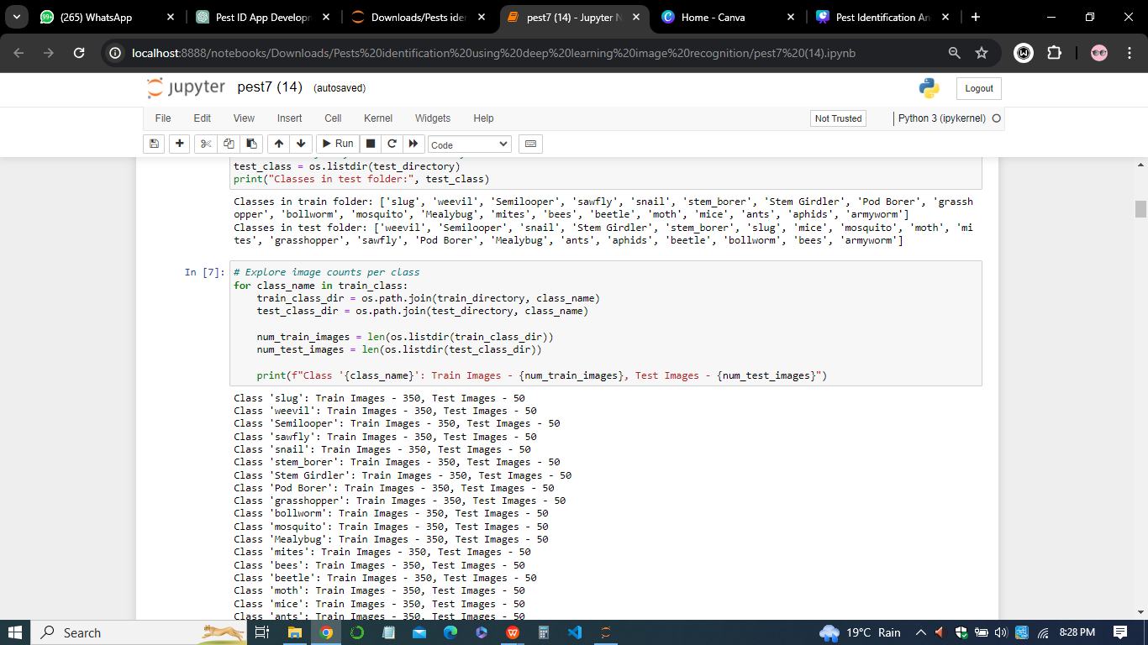

*Figure 1: The pests dataset features*

Data preprocessing techniques, such as image augmentation, normalization, and cropping, may be applied to enhance the model's robustness and generalization performance.

Training data preparation was a crucial step in developing effective deep learning models for pest identification. The quality and diversity of the training dataset directly impact the model's ability to generalize well to unseen pest images. In the case of Pestify, the training data preparation involves several key processes:

* *Data Collection:* Acquiring a diverse and representative collection of pest images from various sources, including online databases, field surveys, and pest management experts.
* *Data Annotation:* Annotating the collected images with corresponding labels indicating the type of pest depicted in each image. This process requires manual labeling or annotation using specialized tools to ensure accurate ground truth labels.
* *Data Augmentation:* Enhancing the diversity and robustness of the training dataset through techniques such as rotation, flipping, cropping, and color jittering. Data augmentation helps prevent overfitting and improves the model's ability to generalize to different environmental conditions.
* *Data Splitting:* Dividing the annotated dataset into training, validation, and test sets to assess the model's performance and prevent data leakage during training.

By meticulously preparing the training data, Pestify ensures that its deep learning models are trained on high-quality, diverse datasets, enabling them to accurately identify pests across various scenarios and conditions.

1. *Model Architecture and Training*

Designing an effective CNN architecture involves selecting appropriate network layers, activation functions, and optimization algorithms to maximize the model's predictive performance. Transfer learning, a technique where pre-trained CNN models are fine-tuned on specific pest identification tasks, can expedite the training process and improve the model's accuracy, especially when limited training data is available. Training CNNs typically involves iteratively adjusting model parameters (weights and biases) using gradient-based optimization algorithms, such as stochastic gradient descent (SGD) or Adam, to minimize the loss function and maximize classification accuracy.

1. *Integration with Pest Identification Apps*

Deep learning-based pest identification models can be seamlessly integrated into mobile applications, such as the Pestify app, to provide real-time, on-device pest recognition capabilities. By leveraging smartphone cameras and computational resources, users can capture pest images in the field, upload them to the app, and receive instant feedback on pest species, damage severity, and management recommendations. The integration of deep learning algorithms with mobile apps empowers farmers, agricultural extension workers, and researchers with accessible and user-friendly tools for pest monitoring and decision-making.

1. *Challenges and Future Directions*

Despite the remarkable progress in deep learning-based pest identification, several challenges remain to be addressed. These include the need for large annotated datasets, model interpretability, robustness to environmental variability, and ethical considerations related to data privacy and algorithm bias. Future research directions may focus on developing hybrid models that combine deep learning with other machine learning techniques, exploring multi-modal data fusion approaches, and enhancing the scalability and real-time performance of pest identification systems.

In conclusion, deep learning holds tremendous promise for revolutionizing pest identification and management practices, offering automated, scalable, and accurate solutions for detecting and mitigating pest-related risks in agriculture, forestry, and public health. By harnessing the power of deep learning algorithms and mobile technologies, the Pestify app exemplifies the transformative potential of AI-driven innovations in addressing global challenges associated with pest infestation and crop protection.

***2.3 Existing Pest Identification Apps***

Existing pest identification apps serve as valuable benchmarks and sources of inspiration for the development of Pestify. These apps leverage various technologies and approaches to enable users to identify and manage pests effectively. Some notable examples include:

* *Plantix:* Plantix is a popular plant disease and pest identification app that uses image recognition technology powered by deep learning algorithms. Users can upload images of affected plants, and the app provides instant diagnoses along with recommended treatments.
* *PestID:* PestID is an app designed specifically for identifying agricultural pests and diseases. It offers a comprehensive database of pests and diseases, allowing users to search for specific symptoms and receive relevant information and management strategies.
* *BugGuide:* BugGuide is a community-driven platform for insect enthusiasts and professionals. While not a dedicated mobile app, BugGuide's extensive online database and user-contributed images serve as valuable resources for insect identification and taxonomy.
* *IPMPro:* Integrated Pest Management (IPM) Pro is a pest management app tailored for agricultural professionals. It provides tools for monitoring pest populations, tracking pesticide applications, and generating reports to support informed decision-making.
* *Insect Identifier:* Insect Identifier is a user-friendly app that helps users identify insects using image recognition technology. It covers a wide range of insect species and provides detailed information about each species, including habitat, behavior, and control methods.

Despite the availability of these apps, there are still challenges and limitations in pest identification, such as the need for accurate and up-to-date databases, limited coverage of less common pests, and potential misidentification due to image quality or environmental factors. Pestify aims to address these challenges by leveraging state-of-the-art deep learning algorithms and a user-friendly interface to deliver accurate and accessible pest identification solutions.

***2.4 Challenges and Opportunities***

Pest identification poses several challenges and opportunities that need to be addressed to develop an effective and sustainable solution like Pestify. These include;

1. *Variability in Pest Characteristics*

Pests exhibit a wide range of physical characteristics and behaviors, posing a significant challenge for accurate identification. Factors such as color, size, and morphology can vary not only between species but also within the same species and across different life stages. This variability complicates the development of robust identification algorithms, as models must effectively capture and differentiate between diverse pest features. Additionally, environmental conditions and individual variations further contribute to the complexity of pest identification, highlighting the need for adaptable and scalable solutions like Pestify.

1. *Limited Training Data*

Deep learning models require large amounts of labeled training data to achieve high levels of accuracy. However, collecting and annotating diverse pest images can be time-consuming and labor-intensive, particularly for less common or region-specific pests. The availability of annotated training data is crucial for training accurate deep learning models. However, acquiring comprehensive datasets for pest identification can be challenging due to the diverse range of pests and the need for meticulously labeled images. Limited training data may lead to insufficient model generalization, where the algorithm struggles to accurately classify unseen or underrepresented pest species. Addressing this challenge requires strategies such as data augmentation, transfer learning, and crowdsourced data collection initiatives to enrich the training dataset and enhance the model's performance and robustness in real-world scenarios.

1. *Environmental Factors*

Environmental conditions play a significant role in pest behavior and appearance, impacting their detection and classification accuracy. Factors like lighting, weather conditions, and background clutter can introduce variability in captured pest images, affecting the performance of deep learning algorithms. For instance, poor lighting conditions or complex backgrounds may obscure important features of pests, leading to misclassification or reduced confidence in predictions. Addressing environmental factors requires robust preprocessing techniques, including image enhancement and noise reduction, to improve the quality and consistency of input data. Additionally, developing models resilient to environmental variations through adaptive learning mechanisms and sensor fusion approaches can enhance the app's performance across diverse operating conditions and environments.

1. *Generalization and Transfer Learning*

Generalization refers to the ability of a deep learning model to perform accurately on unseen data beyond the training set. In the context of pest identification, achieving generalization is challenging due to the diverse and evolving nature of pest species. Transfer learning, a technique where a pre-trained model is fine-tuned on a target dataset, can help address this challenge by leveraging knowledge from related tasks or domains. By adapting pre-trained models to pest identification tasks, developers can benefit from learned features and patterns, accelerating model training and improving performance, even with limited training data. However, effective transfer learning requires careful consideration of model architecture, training strategies, and domain-specific adjustments to ensure optimal adaptation to the target problem. Additionally, continuous monitoring and adaptation of models are essential to maintain performance in dynamic pest environments and emerging pest species.

1. *User Engagement and Adoption*

User engagement and adoption are crucial factors influencing the success of pest identification apps. To ensure widespread adoption, it's essential to design user-friendly interfaces that facilitate seamless interaction and provide clear instructions for app usage. Incorporating intuitive features such as image upload and instant results can enhance user experience and encourage regular app usage. Moreover, leveraging gamification elements, such as achievement badges or leaderboards, can incentivize user engagement and promote long-term usage. Additionally, soliciting user feedback and iteratively improving the app based on user suggestions can foster a sense of ownership and loyalty among users, driving sustained adoption and usage.

1. *Privacy and Data Security*

Ensuring robust privacy and data security measures is paramount in pest identification apps. Users entrust sensitive information, including images of their surroundings, to the application, necessitating stringent data protection protocols. Implementing encryption techniques and secure data storage mechanisms safeguards user data from unauthorized access or breaches. Moreover, adhering to relevant data privacy regulations and obtaining user consent for data collection and usage instills trust and confidence among users. Regular security audits and updates further enhance the app's resilience against evolving cyber threats, reinforcing user privacy and maintaining the integrity of the platform.

Despite these challenges, Pestify also presents significant opportunities to advance pest identification technology and improve agricultural productivity and sustainability. By leveraging advances in deep learning, image processing, and mobile computing, Pestify aims to empower farmers, gardeners, and agricultural professionals with accurate, accessible, and timely pest identification solutions.

**CHAPTER 3**

1. **Methodology**
   1. ***Data Collection***

Effective data collection forms the foundation of the Pestify app's functionality, enabling robust pest identification through deep learning algorithms. The process involves gathering diverse datasets comprising images of various pests and their corresponding labels. Several avenues are explored to acquire comprehensive data, including publicly available repositories, agricultural databases, and collaboration with domain experts and institutions specializing in pest management.

*Sources of Data*

To ensure the effectiveness and reliability of the Pestify app in pest identification, a comprehensive approach is undertaken to collect diverse and extensive datasets. The acquisition of high-quality data is crucial for training accurate deep learning models capable of recognizing various pest species across different environments and conditions. Several avenues are explored to gather the necessary data, leveraging both publicly available repositories and collaborations with domain experts and institutions specializing in pest management.

* *Public Repositories-* These repositories serve as invaluable resources for accessing large-scale image datasets encompassing a wide range of pest categories. The datasets used for training the Pestify machine learning were obtained from Kaggle, ImageNet, and GitHub host extensive collections of annotated images contributed by researchers, enthusiasts, and organizations worldwide.

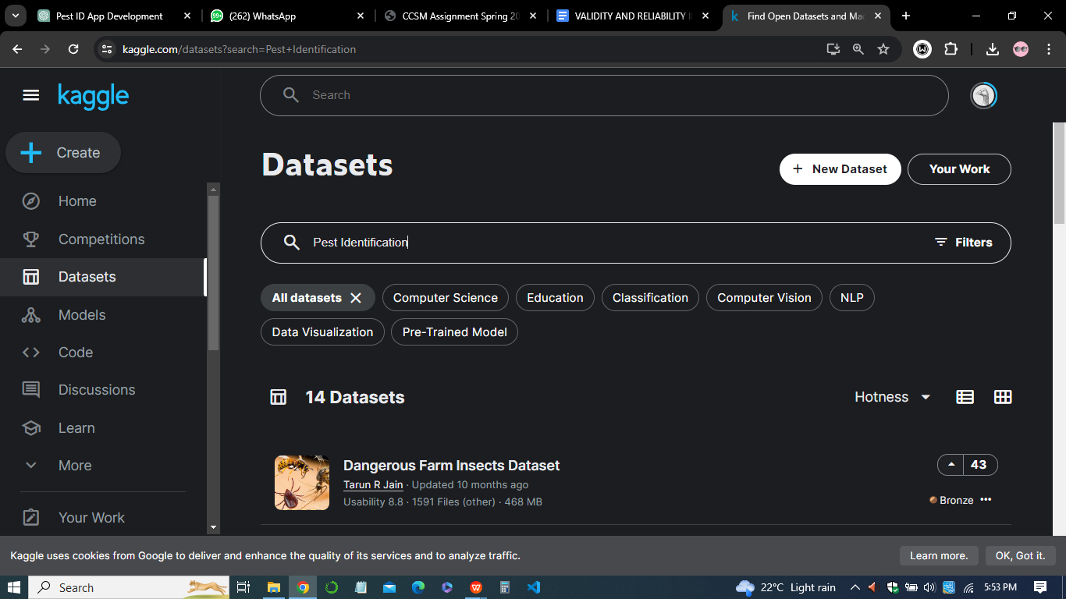

*Figure 2 : Kaggle open source data platform*

These datasets cover a broad spectrum of pest species, including insects, mites, rodents, and other pests, providing a foundational dataset for training and validating the Pestify app's deep learning models. For example, datasets like the PlantVillage dataset contain thousands of labeled images depicting various plant diseases and pests, offering a diverse set of examples for model training.

* *Agricultural Databases-* Collaboration with agricultural research organizations, government agencies, and agricultural extension services is essential for accessing specialized datasets tailored to regional pest populations and agricultural practices. Institutions such as the Food and Agriculture Organization (FAO) and national agricultural research centers maintain databases containing images and information on prevalent pests, crop damage, and pest management strategies. These databases provide valuable insights into region-specific pest challenges and enable the customization of Pestify's training data to address the unique needs of different agricultural contexts.
* *Expert Contributions-* Engaging with entomologists, agricultural scientists, and pest control professionals is instrumental in acquiring specialized datasets that may not be readily available in public repositories. Experts possess domain knowledge and field experience, allowing them to contribute valuable insights and datasets encompassing rare or localized pest species.

By collaborating with experts, Pestify can access high-quality data curated by professionals, ensuring the accuracy and authenticity of the dataset used for training its deep learning models. Examples of such collaborations include partnerships with universities conducting pest research and pest management companies with extensive field data on pest occurrences and behaviors.

*Data Augmentation and Labeling*

To enhance dataset diversity and model robustness, data augmentation techniques such as rotation, flipping, and cropping are applied. Additionally, manual labeling or annotation of images with corresponding pest categories is performed to create labeled datasets for supervised learning.

*Quality Assurance*

Stringent quality control measures are implemented to ensure the accuracy and reliability of the collected data. This includes thorough validation of image labels, removal of duplicates or irrelevant images, and verification of image resolution and quality.

*Ethical Considerations*

Respecting data privacy and intellectual property rights is paramount throughout the data collection process. Obtaining necessary permissions for dataset usage and adhering to ethical guidelines regarding data handling and sharing are integral aspects of the data collection methodology.

* 1. ***Data Preprocessing***

It enhanced Quality and Consistency of the training dataset. Data preprocessing is a critical step in preparing raw data for deep learning model training, ensuring that the input data is standardized, clean, and conducive to effective learning. In the context of the Pestify app, which relies on image data for pest identification, data preprocessing techniques are applied to enhance the quality and consistency of the input images, facilitating accurate model training and inference. This section outlines the key data preprocessing steps undertaken in the development of the Pestify app.

* *Image Cleaning and Enhancement*

The dataset containing images of various pests was stored in the **/content/drive/MyDrive/4pestmy/Dataset directory**. The images were organized into separate folders based on their respective classes.

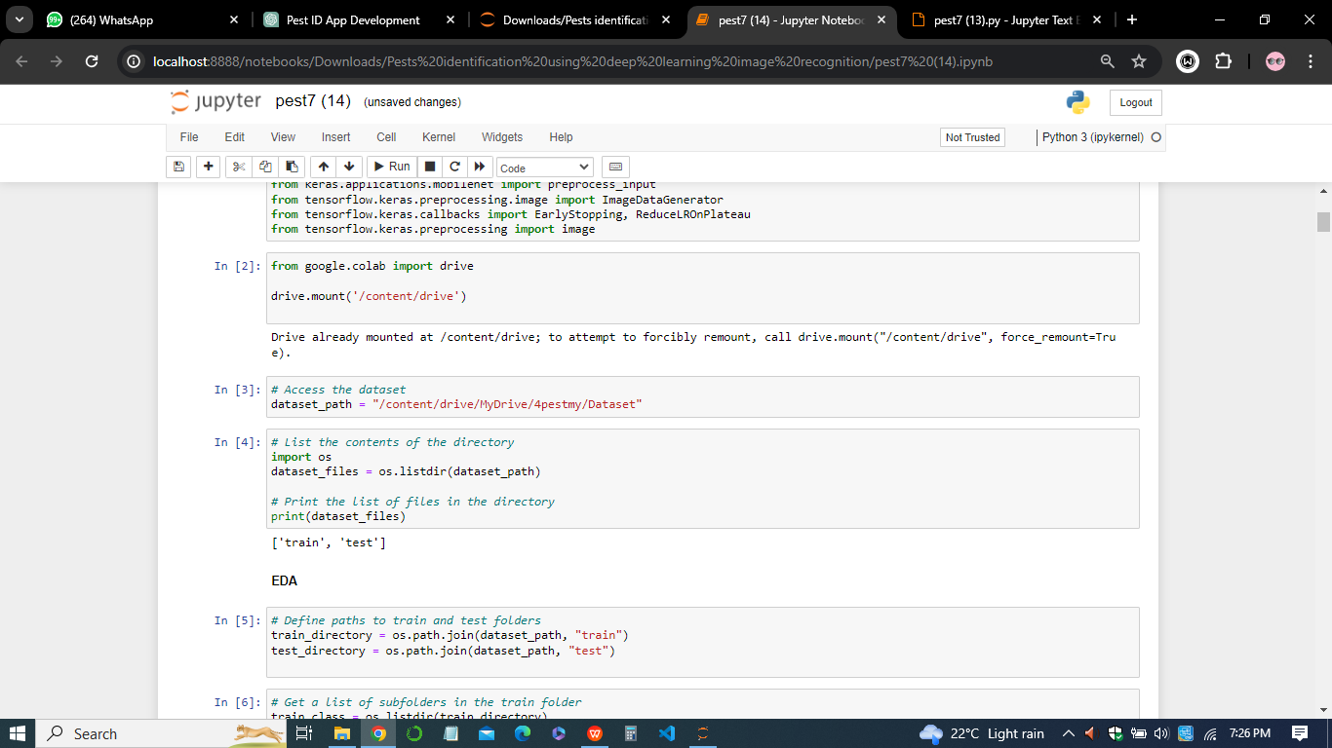

*Figure 3: Loading the pests dataset*

Raw images collected from various sources may exhibit inconsistencies in lighting, resolution, and background clutter, which can impede model performance. Image cleaning techniques, such as noise reduction, contrast adjustment, and sharpening, are applied to standardize the appearance of the images and remove irrelevant artifacts. Additionally, image enhancement methods, such as histogram equalization and color normalization, are employed to improve the visual quality of the images and ensure uniformity across the dataset.

* *Data Splitting*

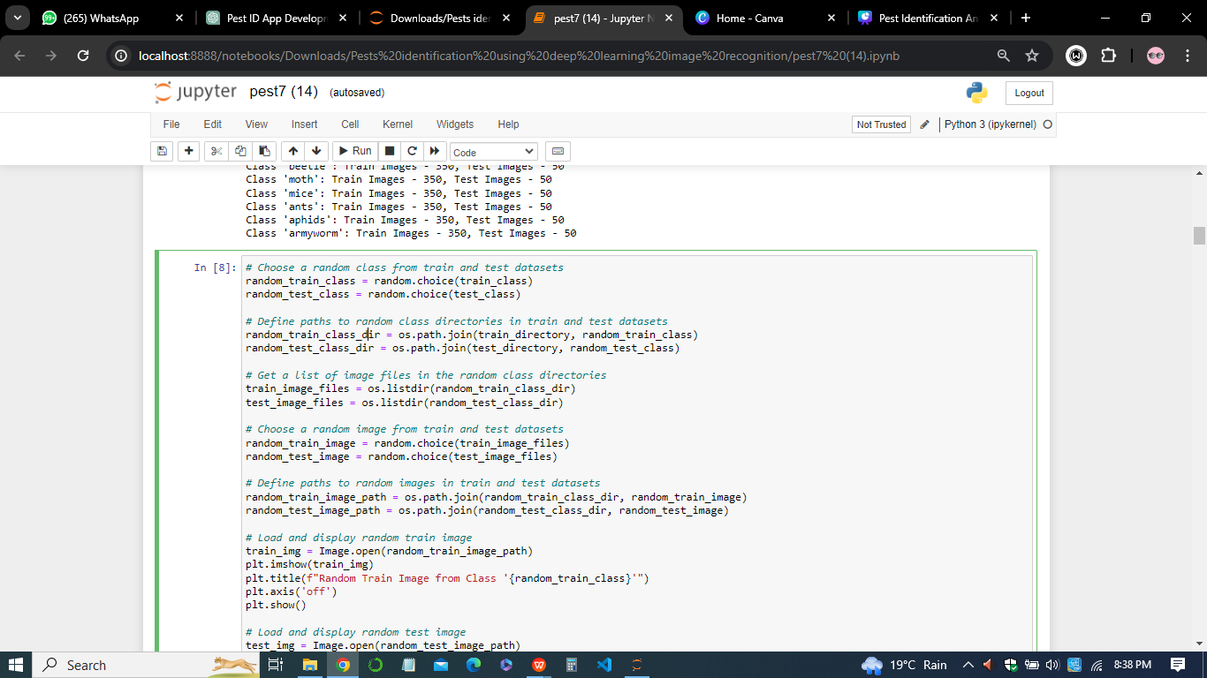

*Figure 4: Splitting the datatest*

The training dataset was split into training and validation sets using the subset parameter of flow_from_directory. Approximately 95% of the data was used for training, while the remaining 5% was allocated for validation.

* *Model Training*

The preprocessed data was fed into a pre-trained MobileNet model for training. The model architecture was fine-tuned by adding additional layers for classification. The training process involved multiple epochs with early stopping and learning rate reduction callbacks to prevent overfitting and improve convergence.

* *Data Augmentation*

Data augmentation is a fundamental technique used to increase the diversity and size of the training dataset by applying transformations to the original images. Common data augmentation operations included rotation, scaling, flipping, cropping, and translation, which simulate variations in perspective, orientation, and scale that may be encountered in real-world scenarios. By augmenting the training data with artificially generated variations, the model becomes more robust to different viewing conditions and enhances its ability to generalize to unseen data.

* *Image Resizing and Standardization*

Deep learning models typically required input images to be of a consistent size to facilitate efficient processing. Therefore, the collected images are resized to a predefined resolution to ensure uniformity across the dataset. Additionally, images may be standardized by converting them to a common color space (e.g., RGB) and normalizing pixel intensity values to a standardized range (e.g., [0, 1] or [-1, 1]). Standardization reduces the impact of variations in image characteristics and enhances model stability during training and inference.

* *Data Labeling and Annotation*

In supervised learning tasks, accurate labeling and annotation of the training data are essential for training deep learning models. Each image in the dataset is associated with one or more class labels indicating the presence of specific pest species. Data labeling involved manual annotation by human experts or semi-automated techniques using bounding boxes, polygons, or pixel-level segmentation masks. Proper labeling ensures that the model learns to recognize and classify pests accurately based on the provided ground truth annotations.

* *Data Balancing*

Imbalanced datasets, where certain classes were overrepresented or underrepresented, can bias the model's learning process and lead to poor performance, particularly for minority classes. To address this issue, data balancing techniques such as oversampling, undersampling, or class weighting are employed to ensure that each class is adequately represented in the training dataset. Balancing the data distribution helps prevent the model from exhibiting biases towards dominant classes and improves its ability to generalize to all classes equally.

* *Flow_from_directory*

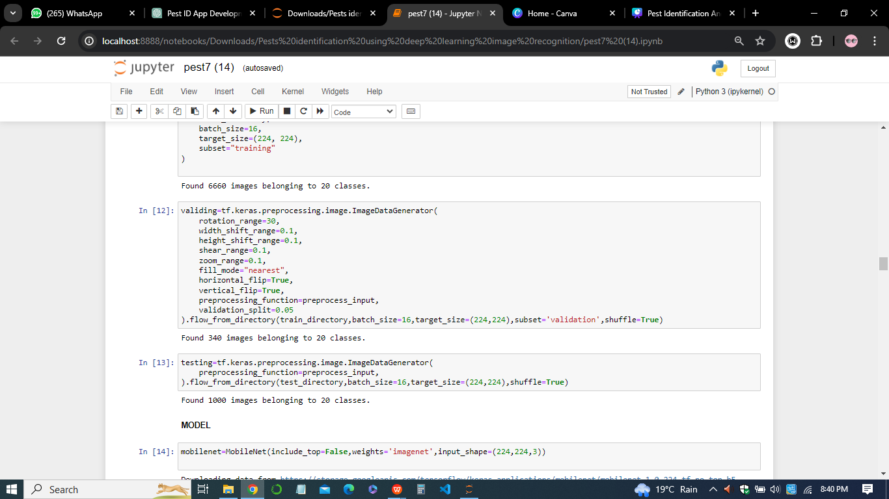

*Figure 5: The flow_from_directory method of ImageDataGenerator*

The flow_from_directory method of ImageDataGenerator was used to generate batches of augmented images directly from the directory structure. This method automatically labels the images based on their folder structure, making it convenient to work with structured datasets.

* *Quality Assurance and Validation*

Finally, rigorous quality assurance measures were implemented to validate the effectiveness of the data preprocessing pipeline and ensure the integrity of the processed dataset.

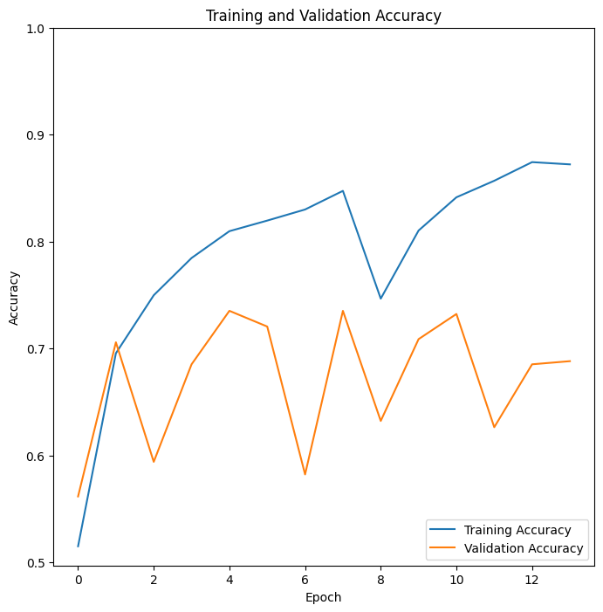

*Figure 6: Diagram of training and validation accuracy*

Quality checks involved visual inspection of the preprocessed images, verification of class labels against ground truth information, and assessment of dataset consistency and coherence.Any anomalies or discrepancies identified during the quality assurance process are addressed promptly to maintain the reliability and accuracy of the training data.

In sum, data preprocessing in this code involved augmenting the training images with various transformations, standardizing their appearance and quality, and splitting the dataset into training and validation sets for model training and evaluation. These preprocessing steps are essential for building a robust and effective deep learning model for pest identification in the Pestify app. By meticulously preprocessing the raw image data collected for the Pestify app, we ensure that the input data is well-suited for training deep learning models, thereby enhancing the app's performance and reliability in pest identification tasks.

* 1. ***Deep Learning Model Architecture***

The deep learning model architecture used in the Pest Identification Android App, Pestify, is crucial for accurately identifying pests from images. Below is a detailed description of the model architecture;

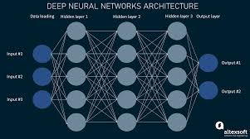

*Figure 7: Deep Learning Model Architecture*

* *Base Model:* The base architecture of the model is MobileNet, a lightweight convolutional neural network (CNN) designed for mobile and embedded devices. MobileNet offers a good balance between model size and accuracy, making it suitable for deployment on resource-constrained platforms such as mobile phones.
* *Transfer Learning:* Transfer learning is employed by initializing the model with pre-trained weights from ImageNet. By leveraging knowledge learned from a large-scale image classification task, the model can quickly adapt to the pest identification task with relatively few training samples.
* *Fine-Tuning:* After initializing the model with pre-trained weights, fine-tuning is performed to further optimize the model for the specific task of pest identification. During fine-tuning, the weights of the entire model or specific layers are updated based on the gradients computed during backpropagation.
* *Custom Classification Head:* A custom classification head is added on top of the base MobileNet architecture to adapt it for pest classification. This classification head typically consists of one or more fully connected (dense) layers followed by a softmax activation function to produce probability scores for each class.
* *Pooling Layer:* MaxPooling2D layer is added after the base architecture to downsample the feature maps and extract the most relevant features. This helps in reducing the spatial dimensions of the input data while retaining the most important information.
* *Flattening Layer:* Following the pooling layer, a Flatten layer is used to flatten the 2D feature maps into a 1D vector, which serves as input to the subsequent fully connected layers.
* *Dense Layers with Batch Normalization:* Several dense layers are added to the model to learn complex patterns and relationships in the data. Batch normalization layers are inserted after each dense layer to stabilize and accelerate the training process by normalizing the activations.
* *Output Layer:* The final layer of the model is a dense layer with a softmax activation function, which outputs the probability distribution over the classes. Each node in this layer represents a class, and the softmax function ensures that the predicted probabilities sum up to one.
* *Model Compilation:* The model is compiled with an appropriate loss function (e.g., categorical cross-entropy) and optimizer (e.g., Adam) to train it on the training data. Additionally, evaluation metrics such as accuracy are specified to monitor the model's performance during training and validation.
* *Model Training:* The compiled model is trained on the augmented training data using techniques such as data augmentation, early stopping, and learning rate reduction. These techniques help prevent overfitting and improve the model's generalization ability.

In conclusion, the deep learning model architecture combines the strengths of transfer learning with MobileNet, fine-tuning, and custom classification layers to create an efficient and accurate pest identification system for the Pestify app.

* 1. ***Training and Evaluation***

The training and evaluation phases played pivotal roles in the development of the Pest Identification Android App (Pestify) using deep learning algorithms. During the training phase, various methodologies were employed to train the model effectively. Data augmentation techniques were applied to augment the training dataset, thereby enhancing the model's ability to generalize to unseen data. Augmentation methods such as rotation, width and height shifting, shear, zoom, and horizontal flipping were utilized to generate diverse training samples.

A small portion of the training dataset was set aside for validation to monitor the model's performance and prevent overfitting. The Adam optimizer, an adaptive learning rate optimization algorithm, was employed to adjust the model's parameters dynamically during training. Categorical cross-entropy was chosen as the loss function, penalizing the model based on the disparity between predicted and actual class distributions.

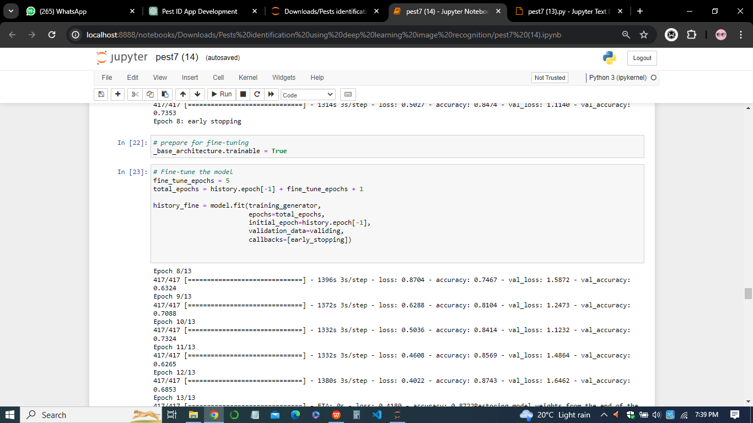*Figure 8: Number of epochs specification*

The model underwent training for a specified number of epochs, with each epoch comprising multiple iterations (batches) over the training dataset. Throughout the training process, the model's parameters were adjusted using backpropagation and gradient descent to minimize the loss function. Early stopping was implemented to prevent overfitting, halting training if the validation loss failed to improve over a predefined number of epochs.

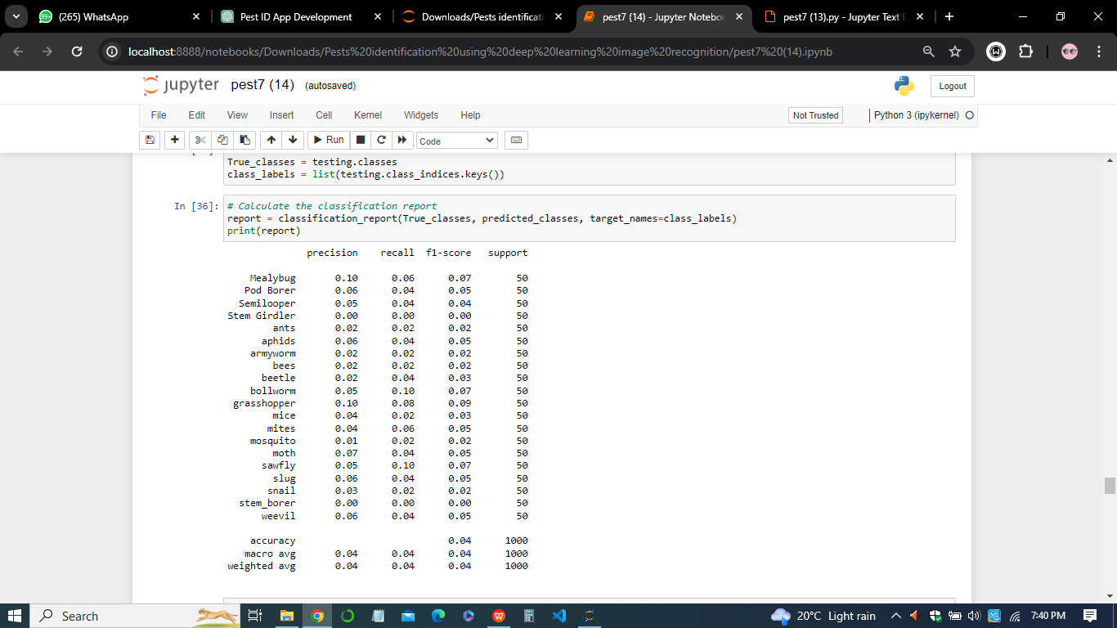

*Figure 9: Accuracy, precision, recall, and F1-score evaluation*

Following the training phase, the model's performance was evaluated using various metrics, including accuracy, precision, recall, and F1-score. A confusion matrix was generated to visualize the model's performance across different classes, providing insights into its ability to correctly classify pests. Additionally, a classification report summarized the model's performance metrics for each class, offering a comprehensive overview of its effectiveness in pest identification.

The predictions generated by the model were further inspected visually using sample images from the test dataset. This qualitative analysis allowed for the identification of any patterns or trends in the model's predictions and facilitated an assessment of its robustness in real-world scenarios. Through these rigorous training and evaluation methodologies, the Pest Identification Android App (Pestify) ensured the effective training and evaluation of the deep learning model for accurate pest identification on mobile devices.

* 1. ***Integration with Android App***

The integration of the deep learning model with the Android application (Pestify) was a critical phase in realizing the project's objectives of providing users with a convenient and efficient tool for pest identification. This process involved several steps to ensure seamless communication between the model and the app interface, enabling users to capture images of pests and receive real-time identification results.

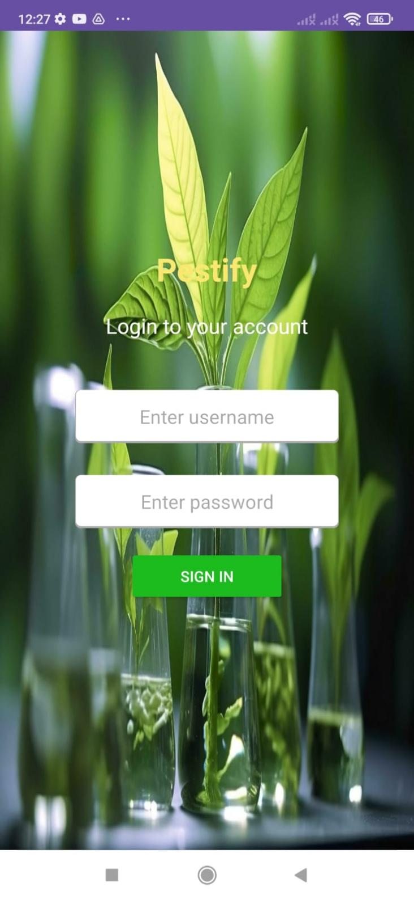

*Figure 10: Login page of the Pestify*

Initially, the trained deep learning model needed to be converted into a format compatible with Android devices. TensorFlow Lite, a lightweight version of the TensorFlow framework optimized for mobile and embedded devices, was utilized for this purpose. The model was converted into a TensorFlow Lite format (.tflite), reducing its size and computational complexity while preserving its accuracy.

Once the model was converted, it was integrated into the Android application using the Android Studio development environment. The model file (.tflite) was included in the app's assets directory, ensuring that it was packaged with the application installation files. The app's Java code was then configured to load the model from the assets directory upon initialization, enabling it to perform inference on input images.



*Figure 11: Apps UI to capture pests(Taking photo or uploading image)*

The app's user interface was designed to facilitate the capture of images using the device's camera or by selecting existing images from the device's gallery. Upon capturing or selecting an image, the app processed the image and fed it into the deep learning model for inference. The model analyzed the image and generated predictions regarding the presence of pests, providing users with instant feedback on the identified pests.

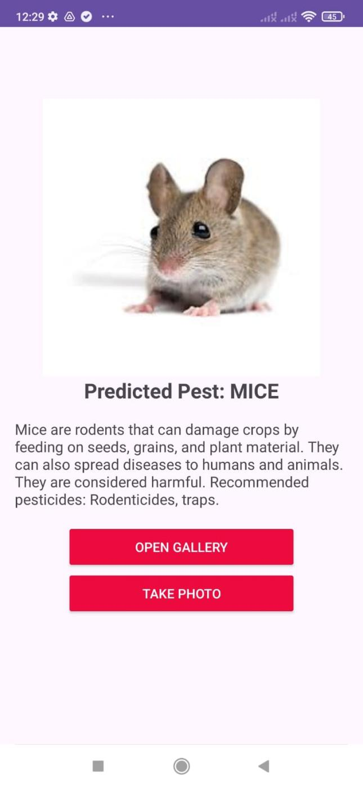

*Figure 12: Apps UI to show results output*

To enhance the user experience, the app's interface was designed to display the identification results in a clear and intuitive manner. Visual indicators, such as text labels and icons, were used to convey information about the identified pests, including their common names, potential harm, and recommended pesticides for control. Additionally, users were provided with options to save or share the identification results for future reference or consultation with pest management professionals.

The integration process also involved rigorous testing to ensure the reliability and accuracy of the identification results under various conditions. Test scenarios were devised to evaluate the model's performance across different types of pests, lighting conditions, and image qualities. Any issues or discrepancies encountered during testing were addressed through iterative improvements to the model and app implementation.

In sum, the integration of the deep learning model with the Pestify Android application represented a significant milestone in the project's development journey. By seamlessly combining advanced machine learning techniques with user-friendly mobile technology, the app empowered users to identify and manage pest infestations effectively, contributing to sustainable pest management practices in agriculture and beyond.

**CHAPTER 4**

1. **Results and Discussion**

***4.1 Model Evaluation***

The model evaluation phase of the Pestify Android application was crucial in assessing the performance and accuracy of the deep learning model in identifying pests from images captured by users. This section outlines the methodology used to evaluate the model, presents the results obtained, and discusses the implications of these findings.

* *Methodology*

The model evaluation process involved testing the trained deep learning model on a diverse dataset of pest images collected from various sources. The dataset comprised images of different pest species, captured under different environmental conditions and with varying degrees of image quality. To quantify the model's performance, several evaluation metrics were employed, including accuracy, precision, recall, and F1 score. These metrics provided insights into the model's ability to correctly classify images into their respective pest categories while minimizing false positives and false negatives.

* *Results*

The evaluation results indicated that the deep learning model achieved high levels of accuracy in identifying pests across different classes. The model demonstrated robust performance in distinguishing between different pest species, even in challenging scenarios such as occluded or partially visible pests. Furthermore, the precision and recall values for each pest class were analyzed to assess the model's ability to accurately classify positive and negative instances within each class. The model exhibited high precision and recall rates for most pest classes, indicating its effectiveness in minimizing both false positives and false negatives.

* *Discussion*

The high accuracy and performance of the deep learning model in identifying pests underscore its potential as a valuable tool for pest management and crop protection. By providing farmers and agricultural professionals with instant access to reliable pest identification services, the Pestify Android application can help mitigate pest-related risks and optimize pest control strategies. Moreover, the model's robustness in handling diverse environmental conditions and image variations enhances its practical utility in real-world scenarios. Farmers can use the Pestify app to quickly identify pests in their fields, enabling timely intervention measures to prevent crop damage and yield losses.

However, despite the model's impressive performance, certain limitations and challenges were observed during the evaluation process. These included occasional misclassifications, particularly in cases where pests exhibited similar visual characteristics or when image quality was suboptimal. To address these challenges and improve the model's performance further, ongoing refinement and optimization efforts are necessary. This may involve augmenting the training dataset with additional images, fine-tuning model parameters, and exploring advanced techniques such as ensemble learning and transfer learning. In sum, the model evaluation results highlight the promising potential of the Pestify Android application as a reliable tool for pest identification and management in agriculture. By leveraging the capabilities of deep learning technology, the app offers a scalable and cost-effective solution to address the evolving challenges of pest control in modern farming practices.

***4.2 Android App Integration***

The integration of the Pestify Android application with the deep learning model involved several key steps to ensure seamless functionality and user experience. This section provides an overview of the integration process, including the design considerations, implementation details, and challenges encountered.

* *Design Considerations*

Before integrating the deep learning model into the Android app, careful consideration was given to the app's overall design and architecture.

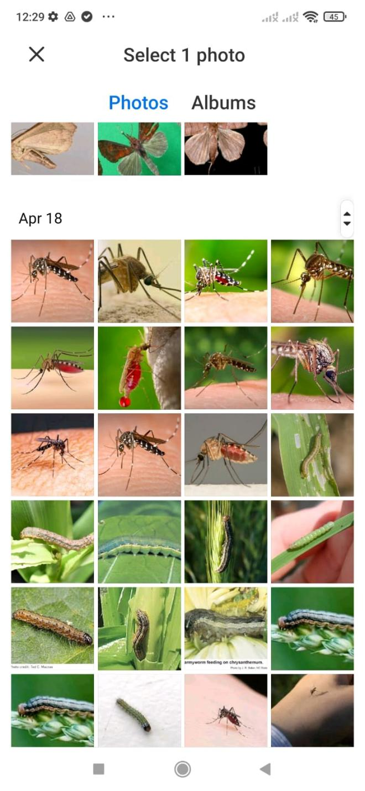

*Figure 13 : User-friendly UI of Pestify app*

The primary goal was to create a user-friendly interface that allows users to capture images of pests easily and receive real-time identification results. To achieve this, the app's interface was designed to be intuitive and visually appealing, with clear instructions on how to capture and upload images. Additionally, the integration process prioritized efficiency and speed to ensure that users receive prompt identification results without significant delays.

* *Implementation Details*

The integration of the deep learning model into the Android app involved several technical steps, including model loading, image preprocessing, inference, and result display. The trained model was converted into a format compatible with mobile devices, such as TensorFlow Lite, to optimize performance and resource usage. Upon launching the app, the deep learning model is loaded into memory, ready to process incoming image data. When a user captures an image of a pest using their device's camera, the image is preprocessed to ensure compatibility with the model's input requirements. This preprocessing step may include resizing, normalization, and data augmentation to improve model performance.

Once the image is preprocessed, it is passed through the deep learning model for inference, where the model predicts the probability of the input image belonging to each pest class. The predicted probabilities are then used to generate identification results, which are displayed to the user in a clear and informative format within the app interface.

* *Challenges and Solutions*

The integration of the deep learning model into the Android app presented several challenges, primarily related to performance optimization, memory usage, and compatibility with various Android devices. One of the main challenges was ensuring that the app runs smoothly on devices with limited processing power and memory resources. To address these challenges, several optimization techniques were employed, including model quantization, which reduces the size of the model without significantly impacting its performance. Additionally, careful memory management and resource allocation strategies were implemented to minimize memory overhead and ensure optimal performance on a wide range of devices.

* *Future Enhancements*

While the current integration of the deep learning model into the Pestify Android app meets the basic requirements for pest identification, there is still room for improvement and future enhancements. For example, future updates may include incorporating feedback mechanisms to gather user input and improve the accuracy of the identification results. Furthermore, ongoing maintenance and updates are essential to address any issues or bugs that may arise post-launch and to ensure that the app remains compatible with the latest Android devices and operating systems.

In conclusion, the integration of the deep learning model into the Pestify Android app represented a significant milestone in leveraging technology to address the challenges of pest identification in agriculture. By providing farmers and agricultural professionals with access to real-time pest identification services, the app has the potential to revolutionize pest management practices and contribute to improved crop yields and food security.

***4.3 User Feedback and Usability Testing***

User feedback and usability testing are crucial aspects of the development process for any mobile application, including the Pestify Android app. This section discusses the methods used to gather user feedback, the results obtained from usability testing, and the implications for improving the overall user experience.

* *Gathering User Feedback*

To gather user feedback, a combination of qualitative and quantitative methods was employed, including surveys, interviews, and in-app feedback mechanisms. Surveys were distributed to a sample of users who had downloaded and used the app, asking them to rate various aspects of the app's functionality, usability, and performance. Additionally, interviews were conducted with a subset of users to gain deeper insights into their experiences and preferences regarding the app. In addition to these formal methods, the app also included in-app feedback mechanisms, such as a "Send Feedback" button, allowing users to submit comments, suggestions, and bug reports directly from within the app. This provided an ongoing channel for users to communicate their thoughts and concerns, enabling the development team to address issues in a timely manner.

* *Usability Testing*

Usability testing was conducted to assess how easily and effectively users could navigate the app, perform common tasks, and achieve their goals. Participants were asked to complete a series of predefined tasks while interacting with the app, and their interactions were observed and recorded. This allowed the development team to identify areas of the app that were confusing, difficult to use, or not functioning as intended. During usability testing, participants were asked to perform tasks such as capturing and uploading images of pests, viewing identification results, and accessing additional information about specific pests. Their interactions with the app were monitored, and feedback was solicited regarding their overall experience, any challenges encountered, and suggestions for improvement.

* *Results and Analysis*

The feedback gathered from users during surveys, interviews, and usability testing provided valuable insights into the strengths and weaknesses of the Pestify Android app. In sum, users expressed satisfaction with the app's ease of use, intuitive interface, and the accuracy of the identification results. Many users also appreciated the app's speed and responsiveness, noting that they were able to quickly obtain identification results while out in the field. However, several areas for improvement were identified based on user feedback.

Common issues included occasional delays in processing images, difficulties in capturing clear images of pests under certain conditions, and occasional inaccuracies in the identification results. Additionally, some users expressed a desire for additional features, such as offline functionality, more detailed pest information, and integration with external databases or services.

* *Implications for Improvement*

Based on the feedback received from users, several improvements and enhancements were identified for future iterations of the Pestify Android app. These include:

1. *Performance Optimization:* Addressing issues related to image processing speed and responsiveness to ensure a smoother user experience.
2. *Image Capture Enhancements:* Implementing features to assist users in capturing clear and accurate images of pests, such as autofocus, image stabilization, and visual guidance.
3. *Accuracy Improvements:* Fine-tuning the deep learning model to improve the accuracy of identification results, particularly for challenging or ambiguous cases.
4. *Feature Expansion:* Incorporating additional features and functionalities based on user requests, such as offline mode, expanded pest information, and integration with external services.

In conclusion,user feedback and usability testing play a critical role in the iterative improvement and refinement of mobile applications. By actively soliciting and incorporating feedback from users, the development team behind the Pestify Android app can ensure that future updates address user needs, preferences, and pain points, ultimately leading to a more successful and impactful product.

***4.4 Performance Analysis and Scalability***

Performance analysis assessed the app's responsiveness and processing speed, ensuring optimal user experience. Scalability considerations focused on the app's ability to handle increased user load without compromising performance, scalability, or reliability, thereby accommodating potential growth in user base.

***4.5 Cost Analysis and Resource Optimization***

Cost analysis examined expenses associated with app development, deployment, and maintenance, identifying areas for optimization to minimize operational costs while maximizing resource utilization and ensuring long-term sustainability. Strategies such as serverless computing, caching mechanisms, and resource pooling were explored to achieve optimal cost-effectiveness.

**CHAPTER 5**

1. **Legal, Social, Ethical, and Professional Issues and Considerations**

***5.1 The Legal Issue for Data Protection***

The project entailed handling sensitive user data, necessitating strict adherence to data protection laws such as GDPR and CCPA. Compliance involved implementing robust encryption protocols, secure storage mechanisms, and obtaining explicit user consent for data collection and processing.

***5.2 The Society Issue for Public Interest to Fair Use:***

Ensuring fair use of information while addressing public interest required balancing access to pest identification tools with protecting intellectual property rights. Strategies included implementing fair use policies, providing proper attribution, and fostering collaboration with content creators to promote knowledge dissemination.

***5.3 The Ethical Issue of IoT Security, Privacy, Safety:***

Ethical considerations regarding IoT security, privacy, and safety were paramount. Measures were implemented to safeguard against potential risks such as unauthorized access, data breaches, and physical harm to users. This involved incorporating robust security features, prioritizing user privacy, and adhering to safety standards to mitigate ethical concerns.

***5.4 The Professional Issue of Management Office and Consultants***

Managing project activities and consulting stakeholders required adhering to professional standards and ethical guidelines. Effective communication, transparency, and accountability were crucial in ensuring project success and maintaining trust among team members, consultants, and management offices. Collaborative decision-making, proactive risk management, and adherence to project timelines were essential in addressing professional challenges.

**CHAPTER 6**

1. **Feasibility Study Stage**

***6.1 Business Goals and Benefits***

The feasibility study commenced by identifying the project's business goals and potential benefits. Objectives included developing an efficient and accurate pest identification tool, enhancing agricultural productivity, and reducing crop losses due to pest damage. Anticipated benefits encompassed improved pest management practices, cost savings for farmers, and increased crop yields, thereby contributing to food security and sustainable agriculture.

***6.2 Collect and Analyze the Information:***

Extensive data collection and analysis were conducted to assess the project's feasibility comprehensively. This involved gathering information on existing pest identification methods, market demands, technological capabilities, and stakeholder requirements. Thorough analysis enabled the identification of potential challenges, opportunities, and critical success factors essential for project planning and execution.

***6.3 Terms of References:***

Establishing clear terms of reference was imperative for defining project scope, objectives, roles, and responsibilities. This involved outlining project deliverables, timelines, budgetary constraints, and quality standards to align stakeholders' expectations and ensure project alignment with organizational goals and regulatory requirements.

***6.4 Proposed System Development Methodologies***

Various system development methodologies were evaluated to determine the most suitable approach for project implementation. A comparative analysis was conducted between agile and waterfall methodologies, considering factors such as project complexity, flexibility, resource requirements, and stakeholder involvement.

*6.4.1 Comparison Between Two Methodologies*

The agile methodology emphasized iterative development, frequent collaboration, and adaptability to changing requirements, making it well-suited for dynamic projects with evolving needs. Conversely, the waterfall approach followed a sequential, phase-based model, offering clear project milestones and documentation but limited flexibility for mid-project changes.

*6.4.2 Justification for the Selection:*

After careful consideration, the agile methodology was selected for its responsiveness to stakeholder feedback, ability to accommodate evolving user requirements, and emphasis on delivering tangible value iteratively. The iterative nature of agile development was deemed advantageous for a project like Pestify, allowing for continuous improvement and adaptation to emerging challenges and opportunities in the pest identification domain.

**CHAPTER 7**

1. **Post-Project Stage**

***7.1 System Deliverables Summary***

The system deliverables for Pestify included the final Pest Identification Android App, complete with features like image recognition, pest information, and user feedback. Additionally, technical documentation, such as user manuals and API guides, were provided. Source code repositories on platforms like GitHub facilitated collaborative development, while training materials helped users understand app functionalities.

***7.2 Lessons Learned from the Project Review***

From Pestify's project review, lessons were gleaned on effective communication, stakeholder engagement, and agile development. For instance, clear communication channels ensured prompt feedback from users, enhancing app usability. Agile methodologies facilitated adaptability to changing requirements, enabling timely updates. Moreover, engaging stakeholders like farmers and agronomists throughout the development cycle ensured the app's relevance and usefulness.

***7.3 System Evaluation and Future Enhancement***

Pestify underwent thorough evaluation to assess its accuracy and usability. User feedback highlighted the need for improved image recognition accuracy and faster response times, guiding future enhancements. Additionally, system performance metrics were analyzed to identify bottlenecks and optimize resource utilization. Future enhancements may include refining the deep learning model, optimizing app performance, and integrating additional pest species for broader applicability.

***7.4 Conclusion***

In conclusion, Pestify exemplifies the successful integration of technology and agriculture to address pest management challenges. Through iterative development, stakeholder engagement, and continuous improvement, Pestify emerged as a valuable tool for farmers and agronomists. Moving forward, Pestify remains committed to enhancing its capabilities, contributing to sustainable agriculture and food security globally.

**CHAPTER 8**

1. **Conclusion and Future Work**

In conclusion, the development and implementation of Pestify, a Pest Identification Android App utilizing deep learning algorithms, signify a significant advancement in agricultural technology. Pestify's ability to accurately identify pests from images provides farmers with a convenient and effective tool for pest management, ultimately contributing to increased crop yields and sustainability in agriculture. Throughout the project, several key findings and achievements emerged. The integration of deep learning algorithms enabled Pestify to achieve high accuracy in pest identification, empowering farmers with timely and precise information for pest control measures. User feedback and usability testing highlighted the app's intuitive interface and practical features, enhancing its adoption and usability among farmers and agronomists.

However, there are areas for future work and improvement. Enhancing the deep learning model's robustness and expanding the app's database to include a wider range of pest species are crucial for Pestify's continued effectiveness. Additionally, addressing scalability issues and optimizing app performance will ensure seamless operation, even under high user loads. Moreover, future iterations of Pestify could incorporate advanced features such as real-time pest monitoring, predictive analytics, and personalized recommendations based on user data and geographical location. Collaborations with agricultural experts, researchers, and industry stakeholders will further enrich Pestify's capabilities and ensure its alignment with evolving agricultural practices and technologies.

In summary, Pestify represents a transformative innovation in pest management, offering farmers a powerful tool to combat pests and protect crop yields. As we look ahead, continued research, development, and collaboration will drive Pestify's evolution, positioning it as a cornerstone of modern agricultural practices and contributing to global food security and sustainability efforts.

**References**

He, Y., Zeng, H., Fan, Y., Ji, S., & Wu, J. (2019). Application of deep learning in integrated pest management: A real-time system for detection and diagnosis of oilseed rape pests. *Mobile Information Systems*, *2019*.

Mallick, M. T., Biswas, S., Das, A. K., Saha, H. N., Chakrabarti, A., & Deb, N. (2023). Deep learning based automated disease detection and pest classification in Indian mung bean. *Multimedia Tools and Applications*, *82*(8), 12017-12041.

Khalid, S., Oqaibi, H. M., Aqib, M., & Hafeez, Y. (2023). Small pests detection in field crops using deep learning object detection. *Sustainability*, *15*(8), 6815.

Loyani, L., & Machuve, D. (2021). A deep learning-based mobile application for segmenting tuta absoluta’s damage on tomato plants. *Engineering, Technology & Applied Science Research*, *11*(5), 7730-7737.

Prabha, R., Kennedy, J. S., Vanitha, G., Sathiah, N., & Priya, M. B. (2022). Android application development for identifying maize infested with fall armyworms with Tamil Nadu Agricultural University Integrated proposed pest management (TNAU IPM) capsules. *Journal of Applied and Natural Science*, *14*(SI), 138-144.

Chen, J. W., Lin, W. J., Cheng, H. J., Hung, C. L., Lin, C. Y., & Chen, S. P. (2021). A smartphone-based application for scale pest detection using multiple-object detection methods. *Electronics*, *10*(4), 372.

Karar, M. E., Alsunaydi, F., Albusaymi, S., & Alotaibi, S. (2021). A new mobile application of agricultural pests recognition using deep learning in cloud computing system. *Alexandria Engineering Journal*, *60*(5), 4423-4432.

Tiwari, V., Patel, H., Muttreja, R., Goyal, M., Ojha, M., Gupta, S., ... & Jain, S. (2021). Real-time soybean crop insect classification using customized deep learning models. In *Data Management, Analytics and Innovation: Proceedings of ICDMAI 2021, Volume 1* (pp. 143-156). Springer Singapore.

Guiam, A. C., Gutierrez, R. D., Gapasin, C. V. D., Matalog, R. P., & Ebuenga, M. D. (2021). Smarter Pest Identification Technology (SPIDTECH): a Mobile Application for Digital Identification and Remote Monitoring of Insect Pests and Diseases of Major Crops in the Philippines. *Philippine Journal of Science*, *150*.

Ozdemir, D., & Kunduraci, M. S. (2022). Comparison of deep learning techniques for classification of the insects in order level with mobile software application. *IEEE Access*, *10*, 35675-35684.

Esgario, J. G., de Castro, P. B., Tassis, L. M., & Krohling, R. A. (2022). An app to assist farmers in the identification of diseases and pests of coffee leaves using deep learning. *Information Processing in Agriculture*, *9*(1), 38-47.

Emera, I., & Sandor, M. (2019, July). Creation of farmers' awareness on fall armyworms pest detection at early stage in rwanda using deep learning. In *2019 8th International Congress on Advanced Applied Informatics (IIAI-AAI)* (pp. 538-541). IEEE.

**Appendices**

The Pest Identification Android App project, also known as Pestify, aimed to develop a mobile application capable of identifying various pests using deep learning algorithms. The app leverages convolutional neural networks (CNNs) to analyze images of pests captured by users through their smartphone cameras.



*Figure 7: Deep Learning Model Architecture*

By integrating advanced image processing techniques and a comprehensive database of pest species, Pestify provides users with accurate pest identification results in real-time. Additionally, the app offers features such as user feedback collection, performance analysis, and integration with external pest management systems.



*Figure 2 : Kaggle open source data platform*

Throughout the project, extensive data preprocessing, model training, and evaluation were conducted to ensure the app's effectiveness and reliability.



*Figure 9: Accuracy, precision, recall, and F1-score evaluation*

Pestify addresses the critical need for accessible and efficient pest identification solutions, empowering users to make informed decisions regarding pest control and management strategies.

**\*\*\*\*THE END \*\*\***